## 12-11-2023-F001 Protokoll Fehler im Log

# Handy Log

# 

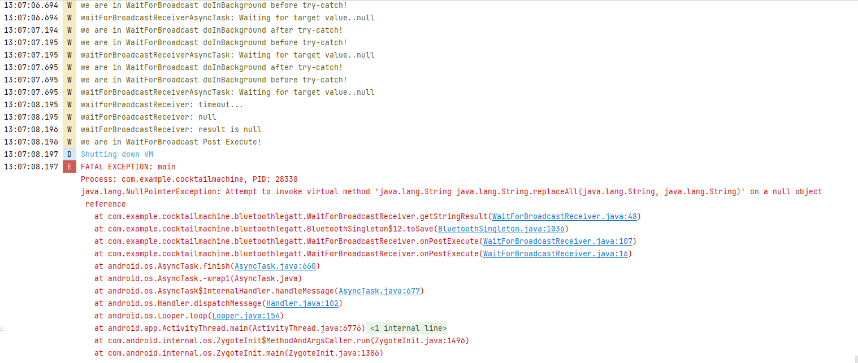

# Bildschirm:

# Esp Log

[2348414][D][esp32.ino:2423] onRead(): read: 0 (eb61e31a-f00b-335f-ad14-d654aac8353d) -> {"user": 17}

[2356214][D][esp32.ino:2408] onRead(): read: 0 (e9e4b3f2-fd3f-3b76-8688-088a0671843a) -> "ready"

[2357336][D][esp32.ino:2433] onWrite(): write: 0 (41044979-6a5d-36be-b9f1-d4d49e3f5b73) -> {"cmd":"define_pumps","user":0,"liquid":"Wasser","volume":100,"quantity":2}

[2357341][D][esp32.ino:1006] parse_command(): processing json: «{"cmd":"define_pumps","user":0,"liquid":"Wasser","volume":100,"quantity":2}»

[2357354][D][esp32.ino:996] add_to_command_queue(): parsed, adding to queue: 0, define_pumps

[2357362][D][esp32.ino:2443] onWrite(): parsed, waiting for queue

[2357362][D][esp32.ino:787] loop(): processing queue (#0): define_pumps (0)

[2357374][D][esp32.ino:2049] update_liquids(): updating pump state

[2357380][D][esp32.ino:2059] update_liquids(): pump: 1, liquid: Wasser, vol: 100.0

[2357388][D][esp32.ino:2059] update_liquids(): pump: 2, liquid: Wasser, vol: 100.0

[2357395][D][esp32.ino:2059] update_liquids(): pump: 3, liquid: Wasser, vol: 100.0

[2357403][D][esp32.ino:2088] update_liquids(): updating liquid state

[2357408][D][esp32.ino:2093] update_liquids(): liquid: Wasser, vol: 300.0

[2357546][D][esp32.ino:2545] config_save(): config saved: 68719476737

[2357547][D][esp32.ino:2357] respond(): sending response to 0: "ok"

[2663103][D][esp32.ino:2390] onDisconnect(): client disconnected:

[2663104][D][esp32.ino:2401] onDisconnect(): 7a:34:a7:6f:47:60 -> 0

# Bemerkungen

Dieser Fehelr tritt in der Konfiguration auf.

5 Sekunden nachdem die Anzahl der Pumpen vom Admin eingegeben wurde sturzt die App ab.